**SECURE SOCKET SHELL(SSH)**

**What is SSH?**

* SSH, also known as **Secure Shell or Secure Socket Shell**, is a cryptographic network protocol that gives users, particularly system administrators, a secure way to access a computer over an unsecured network.
* It’s that provide secure encrypted communications between two untrusted hosts over an insecure network.

**Install OpenSSH Server Software Package:**

* yum install **openssh\***

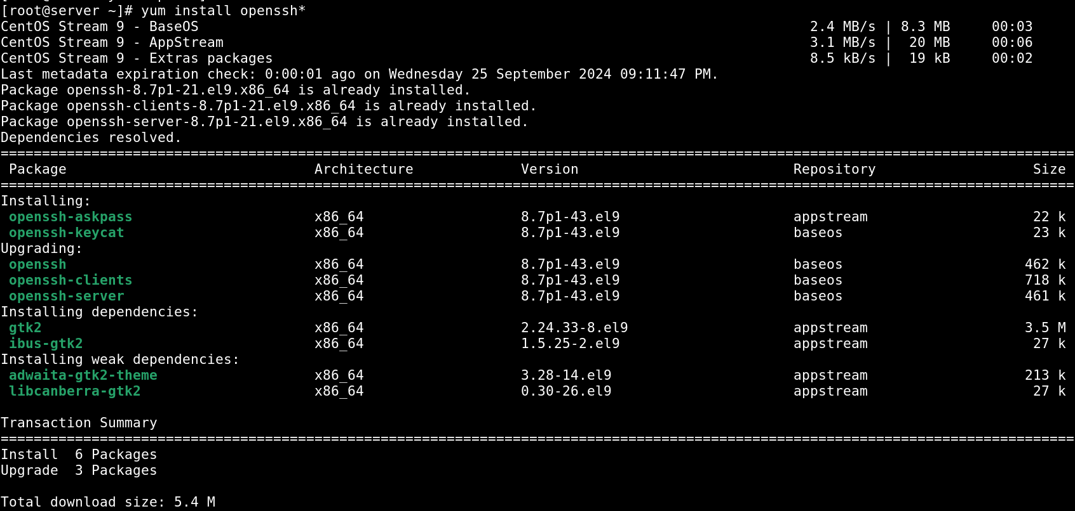

**default port 🡪 22**

**Service Name:**

* **sshd**

**Configuration Files**

* /etc/ssh/sshd_config
* /etc/ssh/ssh_config

**Starting SSH Service**

* systemctl enable --now sshd

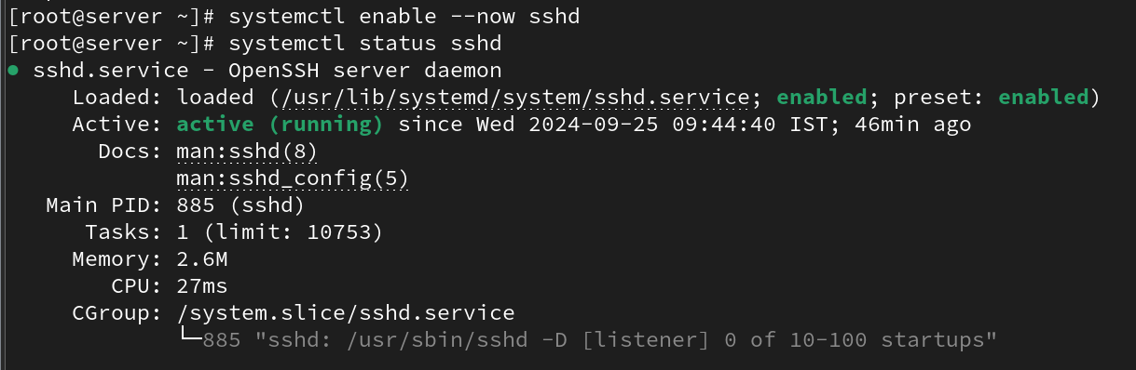

**OpenSSH Server Configuration**

**syntax:**

* vi /etc/ssh/sshd_config

(PermitRootLogin yes)

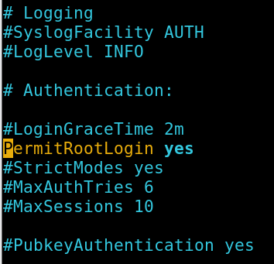

**ssh command:**

**Syntax:**

* ssh <user_name>@ <server_IP> (or)<server_name>

**Example:**

* **ssh root@192.168.45.130**

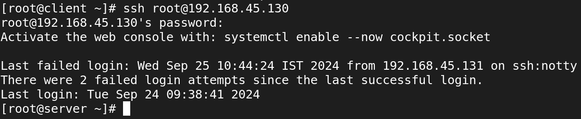

**SECURE COPY (SCP)**

**COPY FILE TO REMOTE SERVER:**

**Syntax:**

* scp <source_file> root@<client_ip>:<destination_file>

**Example:**

* **scp devarun root@192.168.45.130:/root/Music/**

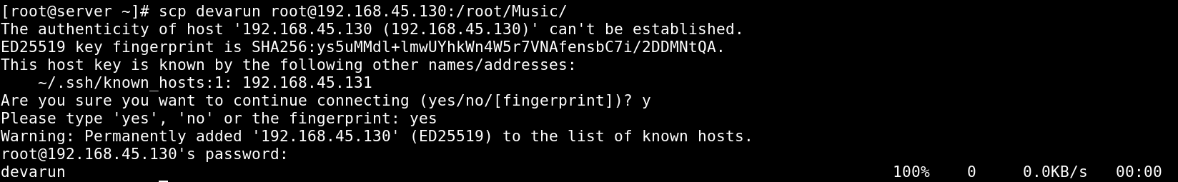

**Now check that the devarun File is copied to Client side:**

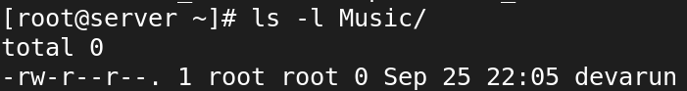

**SSH KEY-GENERATION**

**Synatx:**

* ssh-keygen

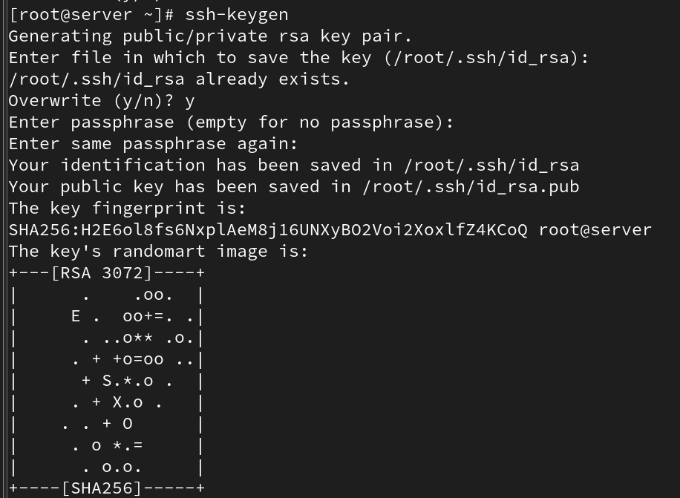

* ssh-copy-id root@192.168.190.128

